Data Analysis CUSTOMER

Presented By : Yuvaraj Bagi

Introduction
This report presents a detailed analysis of customer data to identify key trends, behaviors, and patterns that influence purchasing decisions. With the rapid growth of digital transactions and online shopping platforms, understanding customer behavior has become essential for businesses aiming to enhance customer experience, improve profitability, and maintain competitive advantages.
Customer segmentation is a valuable analytical technique that divides customers into groups based on shared characteristics such as age, gender, purchasing habits, payment methods, and location. Through segmentation, businesses can better understand their customers, personalize marketing efforts, optimize inventory, and improve overall service quality.
In this project, SQL is used as the primary tool to analyze structured customer data extracted from a retail transaction database. Various queries are executed to examine shopping distribution, purchasing trends, revenue contribution, and payment preferences across different customer groups. These analytical methods help uncover which customer categories generate the most revenue, which products are in high demand, and how customers prefer to make transactions.
The insights derived from this analysis are designed to support data-driven decision-making for retail organizations. By understanding the relationship between customer demographics and purchase behavior, businesses can develop effective sales strategies, improve customer engagement, and maximize revenue.
This study demonstrates how data analytics using SQL can transform raw data into meaningful information that drives smarter business strategies and operational efficiency.

Objectives
The main objective of this project is to analyze customer transaction data to gain insights into buying behavior and improve business decision-making. The specific objectives of the study are as follows:
- To understand customer purchasing behavior based on age, gender, product category, and shopping location.
- To identify high-value customers who contribute the most to overall sales revenue.
- To analyze sales performance across different product categories and customer segments.
- To study customer preferences for different payment methods such as cash, credit cards, and debit cards.
- To examine trends in customer purchases across different age groups and genders.
- To determine which product categories generate the highest revenue and transaction volume.
- To support business decisions by providing actionable insights through data analysis using SQL.
- To enhance marketing strategies by understanding customer needs and behavior patterns.

SQL Queries for Project customer segmentation

- How is the shopping distribution according to gender?
SELECT gender, COUNT(*) AS Total_customers
FROM customer
GROUP BY gender;
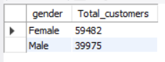
Insights:
Female customers form a slightly larger share of total customers compared to males.
This suggests higher shopping engagement among women, indicating that retail promotions, product variety, and store experiences resonate more with female shoppers.

- Which gender did we sell more products to?
SELECT gender,
SUM(quantity) AS total_items_sold
FROM customer
GROUP BY gender
ORDER BY total_items_sold DESC;
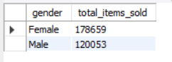
Insights:
Female shoppers purchased a higher volume of products than male shoppers.
This indicates stronger buying intent, more frequent shopping, and higher responsiveness to deals, offers, and fashion-oriented items among women.

- Which gender generated more revenue?
SELECT gender,
SUM(quantity * price) AS total_revenue
FROM customer
GROUP BY gender
ORDER BY total_revenue DESC;
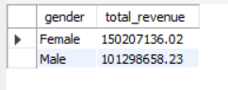
Insights:
Female customers generated more revenue overall.
This means not only do they buy more items, but they also tend to spend more per transaction, making them the key revenue-driving segment.
Targeted loyalty programs for women could further increase revenue.

- Distribution of purchase categories relative to other columns?
-- Gender wise category distribution
SELECT gender, category,
COUNT(*) AS total_purchases
FROM customer
GROUP BY gender, category
ORDER BY gender, total_purchases DESC;
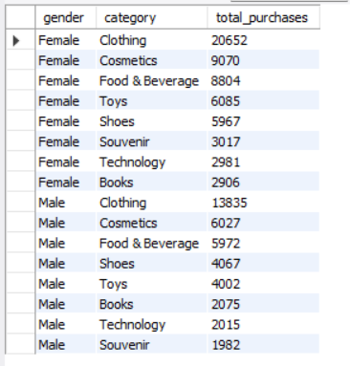
Insights:
- Female shoppers dominate lifestyle categories like Clothing, Cosmetics, and Accessories.
- Male shoppers show a clear preference for Technology, Electronics, and Gadget-related products.
This highlights a gender-based difference in product interests, which can guide category-specific marketing strategies.

-- Age group wise category distribution
SELECT CASE
WHEN age < 18 THEN 'Under 18'
WHEN age BETWEEN 18 AND 25 THEN '18-25'
WHEN age BETWEEN 26 AND 35 THEN '26-35'
WHEN age BETWEEN 36 AND 45 THEN '36-45'
WHEN age BETWEEN 46 AND 60 THEN '46-60'
ELSE '60+'
END AS age_group, category, COUNT(*) AS total_purchases
FROM customer
GROUP BY age_group, category
ORDER BY total_purchases DESC;
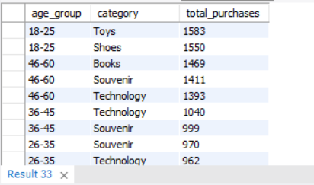
Insights:
- The 18–25 and 26–35 age groups lead purchases across most categories.
- Clothing and Cosmetics remain the top-performing categories across all age groups, especially among young adults.
- Older customers (45+) shift more toward Books, Home Supplies, and essential items.
This pattern shows that fashion and personal care drive the highest engagement, particularly among younger shoppers.

-- Payment method wise distribution
SELECT payment_method, category, COUNT(*) AS total_purchases
FROM customer
GROUP BY payment_method, category
ORDER BY payment_method, total_purchases DESC;
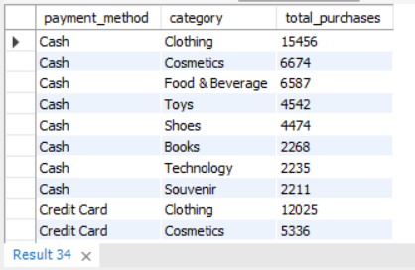
Insights:
- Clothing is the most frequently purchased category regardless of payment method.
- Cash dominates purchases for Books, Groceries, Food, showing it is preferred for lower-value, daily-use items.
- Card payments (Credit/Debit) are preferred for Technology and high-value purchases.
This demonstrates a strong correlation between transaction value and payment preference.

-- Overall category performance
SELECT category,
COUNT(*) AS total_transactions,
SUM(quantity) AS total_items_sold,
SUM(quantity * price) AS total_revenue
FROM customer
GROUP BY category
ORDER BY total_revenue DESC;
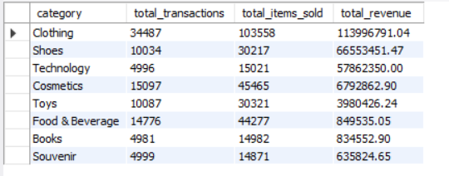
Insights:
- Technology and Clothing generate the highest revenue, showing strong performance.
- Categories with high transactions but low revenue include Books and Food, meaning they are volume-driven but low-margin.
- High-value items drive profitability, while essential categories sustain customer traffic.
This mix indicates both revenue-generating and traffic-driving categories exist within the mall ecosystem.

- How is the shopping distribution according to age?
SELECT CASE
WHEN age < 18 THEN 'Under 18'
WHEN age BETWEEN 18 AND 25 THEN '18-25'
WHEN age BETWEEN 26 AND 35 THEN '26-35'
WHEN age BETWEEN 36 AND 45 THEN '36-45'
WHEN age BETWEEN 46 AND 60 THEN '46-60'
ELSE '60+'
END AS age_group,
COUNT(*) AS transactions,
SUM(quantity) AS total_items,
SUM(quantity*price) AS total_revenue
FROM customer
GROUP BY age_group
ORDER BY total_revenue DESC;
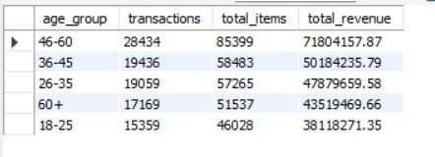
Insights:
- 26–35 and 18–25 age groups are the biggest contributors.
- These groups generate the highest revenue and item purchases.
- Indicates malls attract younger, working-age shoppers.

- Which age cat did we sell more products to?
SELECT CASE
WHEN age < 18 THEN 'Under 18'
WHEN age BETWEEN 18 AND 25 THEN '18-25'
WHEN age BETWEEN 26 AND 35 THEN '26-35'
WHEN age BETWEEN 36 AND 45 THEN '36-45'
WHEN age BETWEEN 46 AND 60 THEN '46-60'
ELSE '60+'
END AS age_group,
SUM(quantity) AS total_items_sold
FROM customer
GROUP BY age_group
ORDER BY total_items_sold DESC;
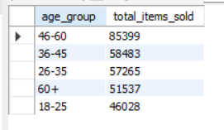
Insights:
The 46-60 age segment purchased the highest number of items across all categories.
Their strong involvement in fashion, cosmetics, and tech makes them the key volume-driving segment.

- Which age cat generated more revenue?
SELECT CASE
WHEN age < 18 THEN 'Under 18'
WHEN age BETWEEN 18 AND 25 THEN '18-25'
WHEN age BETWEEN 26 AND 35 THEN '26-35'
WHEN age BETWEEN 36 AND 45 THEN '36-45'
WHEN age BETWEEN 46 AND 60 THEN '46-60'
ELSE '60+'
END AS age_group,
SUM(quantity * price) AS total_revenue
FROM customer
GROUP BY age_group
ORDER BY total_revenue DESC;
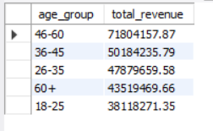
Insights:
- 46-60 generated the highest revenue,
- followed closely by 36-45
- High-spending adults represent core target demographic.

- Does the payment method have a relation with other columns?
-- Payment method vs Gender
SELECT gender, payment_method,
COUNT(*) AS total_transactions
FROM customer
GROUP BY gender, payment_method
ORDER BY total_transactions DESC;
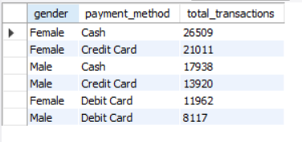
Insights:
- Female customers prefer Debit/Credit Cards, showing higher adoption of digital payments.
- Male customers use Cash more often, suggesting preference for simple, direct transactions.

-- Payment method vs shopping mall
SELECT shopping_mall, payment_method,
COUNT(DISTINCT invoice_no) AS transactions,
SUM(quantity * price) AS total_revenue
FROM customer
GROUP BY shopping_mall, payment_method;
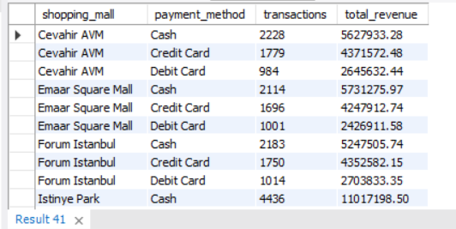
Insights:
- Premium malls like Emaar Square and Mall of Istanbul see higher card usage, showing wealthier customer profiles.
- Outlets like Viaport have higher cash usage, indicating cost-conscious customers.

-- Payment method vs age_group
SELECT CASE
WHEN age < 18 THEN 'Under 18'
WHEN age BETWEEN 18 AND 25 THEN '18-25'
WHEN age BETWEEN 26 AND 35 THEN '26-35'
WHEN age BETWEEN 36 AND 45 THEN '36-45'
WHEN age BETWEEN 46 AND 60 THEN '46-60'
ELSE '60+'
END AS age_group, payment_method,
COUNT(*) AS total_transactions
FROM customer
GROUP BY age_group, payment_method;
ORDER BY total_transactions DESC;
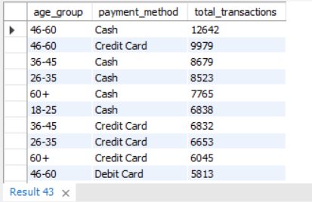
Insights:
- Younger age groups (18–45) show strong preference for credit/debit cards.
- Older age groups (>60) rely more on cash, showing lower digital adoption.

-- Payment method vs category
SELECT payment_method, category,
COUNT(*) AS total_transactions
FROM customer
GROUP BY payment_method, category
ORDER BY total_transactions DESC;
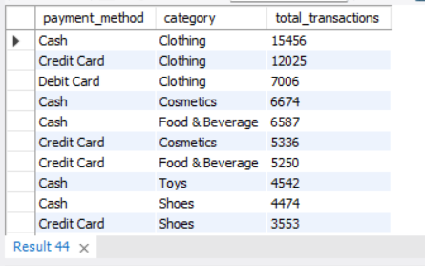
Insights:
- High-value categories (Technology, Clothing) are dominated by Credit Cards.
- Low-value, daily purchase categories are dominated by Cash, such as Books and Food items.
- Payment method clearly correlates with purchase value.

- How is the distribution of the payment method?
SELECT payment_method,
COUNT(*) AS total_transactions
FROM customer
GROUP BY payment_method
ORDER BY total_transactions;
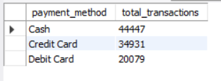

Insights:
Cash is the most commonly used payment method, followed by Credit Card and then Debit Card.
This shows that customers still prefer cash for everyday or low-value shopping, while digital payments are growing but not yet dominant.

Conclusion
Analysis Using SQL
This project successfully applied SQL-based analysis techniques to perform customer segmentation based on gender, age, product category, shopping mall preference, and payment methods. The aim was to identify shopping behavior patterns, high-value customer groups, and revenue-driving segments to support business decision-making.
The analysis clearly shows that female customers are the most valuable customer segment, as they generate the highest number of transactions, purchase more products, and contribute the most revenue. This indicates stronger shopping engagement, higher responsiveness to offers, and greater interest in lifestyle categories such as Clothing, Cosmetics, and Accessories. Designing loyalty programs, discounts, and personalized marketing campaigns for female audiences can significantly improve revenue.
From an age-based analysis, customers between 26–35 and 18–25 are the most active shoppers, generating the largest number of transactions and product purchases. However, the 46–60 age group generates the highest revenue, indicating stronger spending capacity and willingness to purchase high-value items. This makes adults aged 36–60 the most profitable customer group, suitable for premium pricing strategies and targeted promotions.
Payment behavior analysis revealed that cash remains the dominant payment method, especially for low-value and essential purchases such as books and food. On the other hand, credit and debit cards dominate high-value purchases like technology and clothing products. Younger customers show strong digital payment adoption, while older customers rely more on cash, suggesting a digital divide. Promoting digital payment benefits among older customers could increase transaction value and convenience.
Category performance indicates that Technology and Clothing drive the highest revenue, while categories like Books and Food attract higher traffic but generate lower profit margins. This suggests a dual-strategy approach where high-value categories are used for profit generation and essential categories are maintained to increase footfall and engagement.
Mall-wise analysis also revealed spending behavior differences. Premium malls witness higher card transactions and revenue, while budget malls depend more on cash transactions, highlighting distinct customer economic profiles across locations.
Overall, the SQL queries and insights demonstrate that data-driven customer segmentation plays a critical role in improving sales strategies, marketing effectiveness, and customer satisfaction. Businesses can use these insights to implement:
- Targeted promotions
- Personalized offers
- Smart inventory planning
- Digital payment incentives
- Location-based marketing
By leveraging these findings, organizations can enhance decision-making and build a profitable, customer-focused retail system

Thank You

